INSTITUCIÓN EDUCATIVA NORMAL SUPERIOR DE ENVIGADO

NOMBRE: __________________________________________________

GRADO:

1. **INVESTIGA LAS SIGUIENTES PALABRAS:**RANGO: ____________________________________________________________________________________________________________________  
     
   PROMEDIO: ____________________________________________________________________________________________________________________  
     
   FÓRMULA: ____________________________________________________________________________________________________________________
2. UNE CON UNA LÍNEA

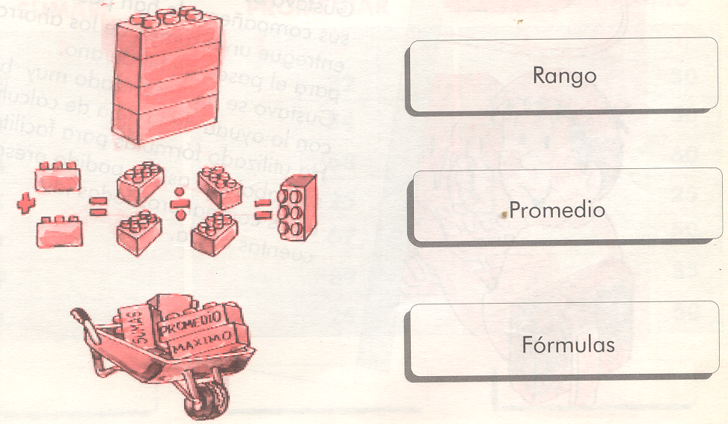

1. **INVESTIGA LAS SIGUENTES PALABRAS:**  
   FILA: ____________________________________________________________________________________________________________________  
     
   COLUMNA: ____________________________________________________________________________________________________________________  
     
   HOJA DE CÁLCULO: ____________________________________________________________________________________________________________________
2. **UNE CON UNA LÍNEA**

